MUTUAL FUND ANALYSIS
Project overview-
In today’s dynamic investment landscape, choosing the right mutual fund requires a careful balance of risk, returns, and credibility.
This analysis examines top-performing funds top-performing funds by reviewing key metrics such as ratings, 1-month, 1-year, and 3-year returns, NAV, minimum investment, fund managers, AUM, category, and risk profile. Leveraging interactive dashboards with KPI cards, charts, and filters, it provides a clear, data-driven view to guide informed and strategic investment decisions.
Objective and purpose-
The objective of this analysis is to provide a clear and comprehensive evaluation of mutual funds, examining performance, risk, ratings, and key investment metrics.
Its purpose is to empower investors with actionable insights through interactive dashboards, important insights, enabling informed, strategic, and data-driven investment decisions.
Problem Statement-
Investors often face difficulty in selecting suitable mutual funds due to the availability of numerous funds with varying returns, risk levels, ratings, and fund management strategies.
The lack of a unified and structured view of key performance indicators—such as returns over different time horizons, ratings, NAV, AUM, and risk categories—makes comparative analysis complex and time-consuming.
This project addresses the need for a comprehensive, data-driven mutual fund analysis that consolidates critical metrics into an interactive dashboard, enabling clear comparison, performance evaluation, and informed investment decision-making.
Importance and Relevance-
Mutual fund investments play a critical role in long-term wealth creation, yet informed decision-making remains a challenge due to market complexity and data overload.
This analysis is important as it transforms raw mutual fund data into meaningful insights by evaluating returns, risk, ratings, and fund performance across multiple dimensions.
Its relevance lies in providing investors, analysts, and financial professionals with a clear, comparative, and data-driven framework to assess fund suitability, identify top performers, and align investment choices with financial goals and risk appetite.
Tools and Technologies Used -
1. Microsoft Excel & Python (Pandas)
Microsoft Excel, along with Python’s Pandas library, was used for initial data cleaning and preparation of the mutual fund dataset. This included removing duplicate records, handling missing values, correcting data types, and standardizing formats for fields such as returns, NAV, AUM, and ratings. This step ensured data accuracy, consistency, and reliability, forming a strong foundation for meaningful analysis.
2. SQL
SQL was utilized to extract and analyze insights from the cleaned mutual fund data. Through filtering, grouping, and aggregation queries, key trends such as top-performing funds, return-based comparisons, category-wise and risk-wise performance, and AMC-level analysis were identified. SQL enabled efficient handling of structured data and quick generation of summary-level insights.
3. Python for Advanced Analysis
The SQL-processed data was further analyzed using Python to perform advanced calculations and classifications. This included computing return contributions, identifying performance patterns across risk and category segments, and ranking funds, fund managers, and AMCs. Python enabled deeper analytical insights beyond basic aggregations, supporting data-driven investment evaluation.
4. Matplotlib
Matplotlib was used to visualize key insights through charts and graphs such as line charts, bar charts, stacked columns, and funnel visuals. These visualizations helped clearly represent trends in returns, AUM distribution, category performance, and risk-based comparisons, making the analysis more intuitive and actionable.
5. Python Automation (openpyxl)
Python automation using the openpyxl library was implemented to export analyzed data and corresponding visualizations into structured Excel sheets. Each sheet represents a distinct insight related to mutual fund performance, ensuring a well-organized, presentation-ready output. This automated approach reduced manual effort, improved efficiency, and maintained consistent formatting across the final deliverables.

Data Analysis using SQL –
Top 5 Mutual Funds Based on One-Month Return-
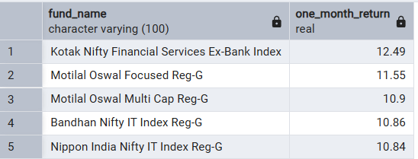
Top 5 Mutual Funds with 5-Star Ratings (Morningstar & Value Research) Based on One-Year Return-
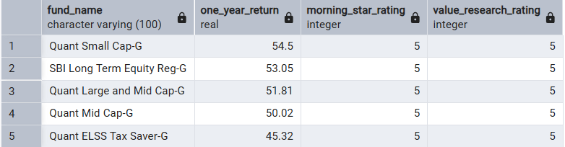
Top 5 Mutual Funds with 5-Star Ratings (Morningstar & Value Research) Based on Three-Year Return –
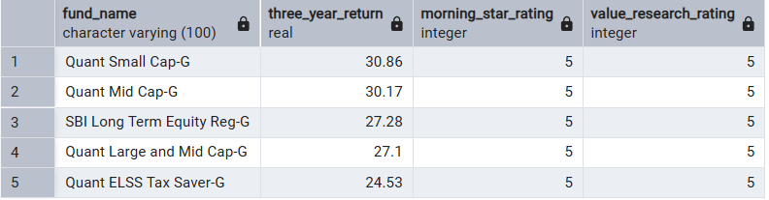
Top 5 Fund Managers Based on One-Month Return –
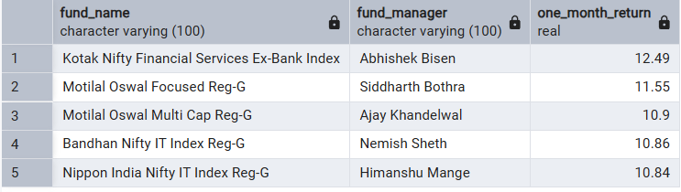
Top 5 Fund Managers Based on One-Year Return-
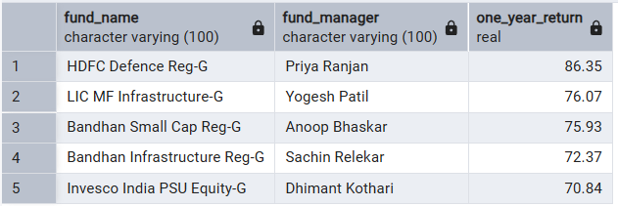
Top 5 Fund Managers Based on Three-Year Return-
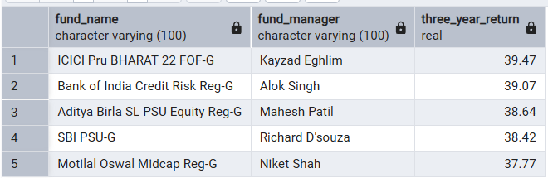
Top 5 Very High-Risk Mutual Funds Based on One-Month Return –
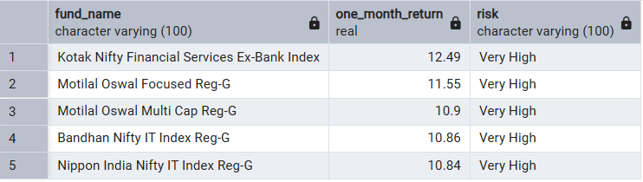
Top 5 Very High-Risk Mutual Funds Based on One-Year Return –
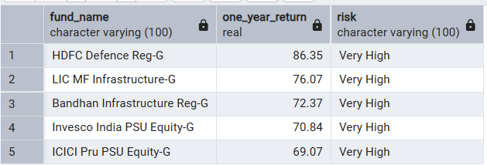

Top 5 Moderately High-Risk Mutual Funds Based on One-Year Return –
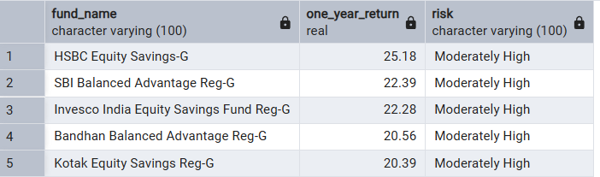
Top 5 Low-Risk Mutual Funds Based on One-Year Return-
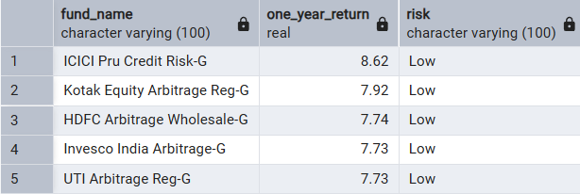
Top 5 Very High-Risk Mutual Funds Based on Three-Year Return –
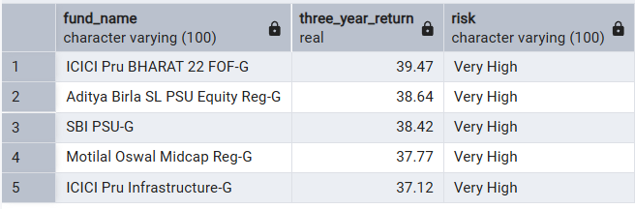
Top 5 Moderately High-Risk Mutual Funds Based on Three-Year Return –
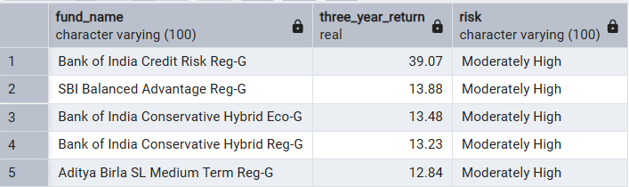

Top 5 Low-Risk Mutual Funds Based on Three-Year Return –
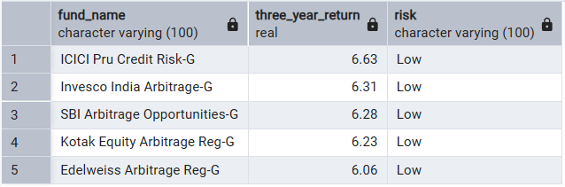
Top 5 Equity Mutual Funds Based on One-Year Return –
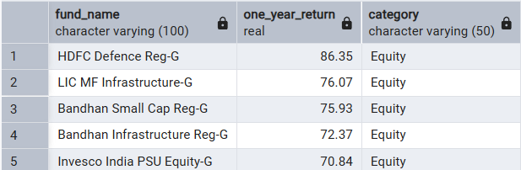
Top 5 Debt Mutual Funds Based on One-Year Return –
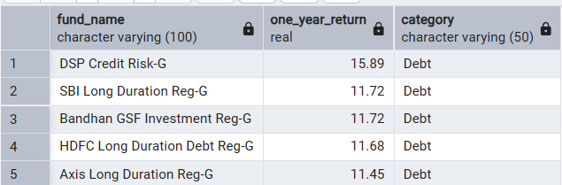
Top 5 Hybrid Mutual Funds Based on One-Year Return –
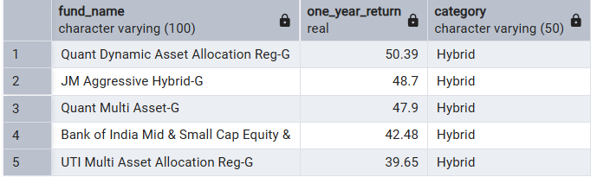
Top 5 Mutual Funds in ‘Other’ Category Based on One-Year Return –
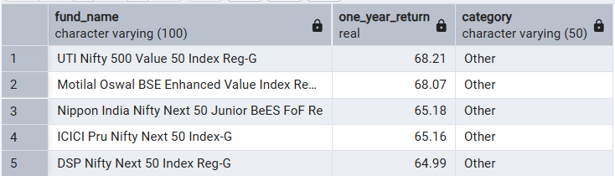
Top 5 Equity Mutual Funds Based on Three-Year Return –
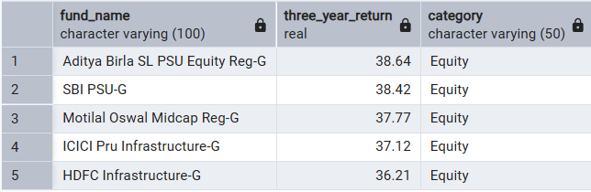
Top 5 Debt Mutual Funds Based on Three-Year Return –
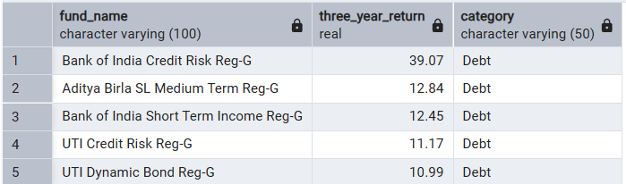
Top 5 Hybrid Mutual Funds Based on Three-Year Return –
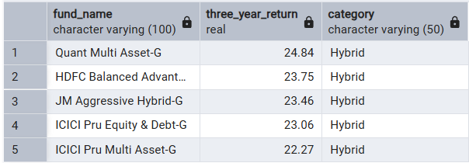
Top 5 Mutual Funds in ‘Other’ Category Based on Three-Year Return –
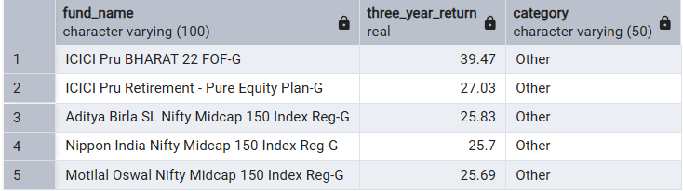
Top 5 Mutual Funds Based on Assets Under Management (AUM) –
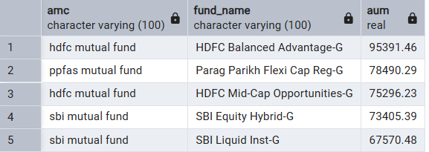
Most expensive mutual fund –
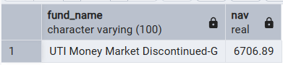
Top 3 Fund Managers Based on Three-Year Return –
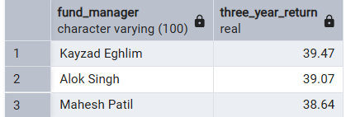
Most trusted AMC by AUM –
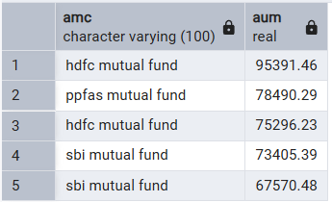
Python Automation using Openpyxl –
Top 5 Debt Mutual Funds Based on Three-Year Return –
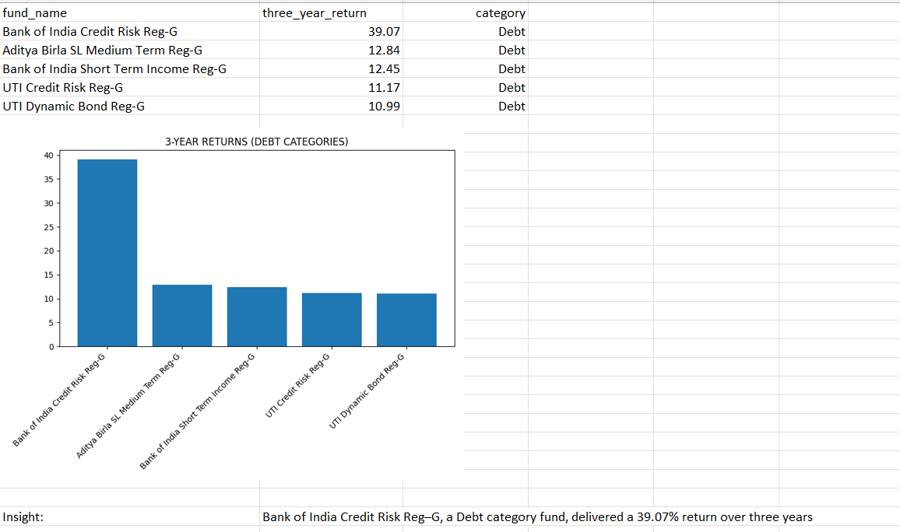
Top 5 Equity Mutual Funds Based on Three-Year Return –
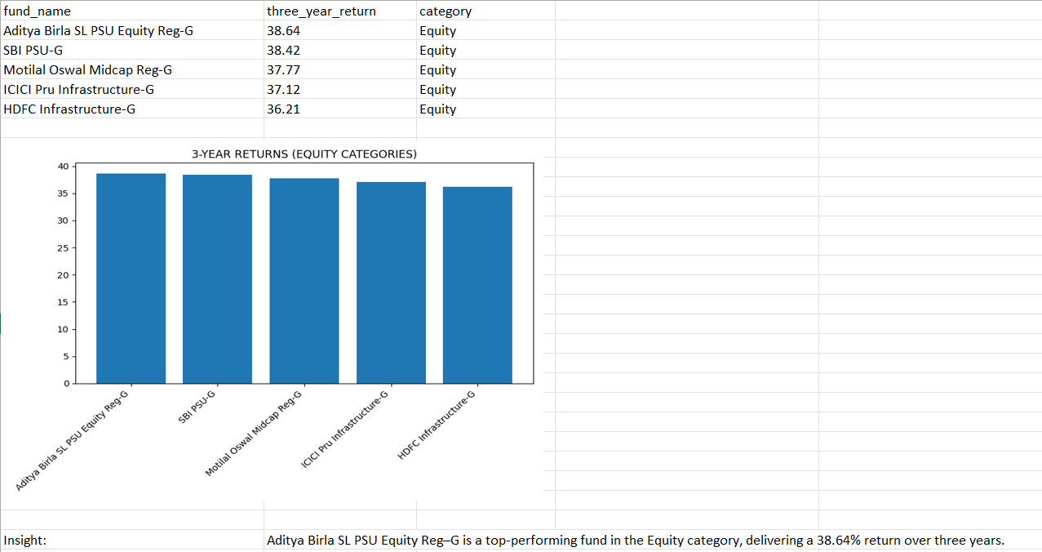
Top 5 Hybrid Mutual Funds Based on Three-Year Return –
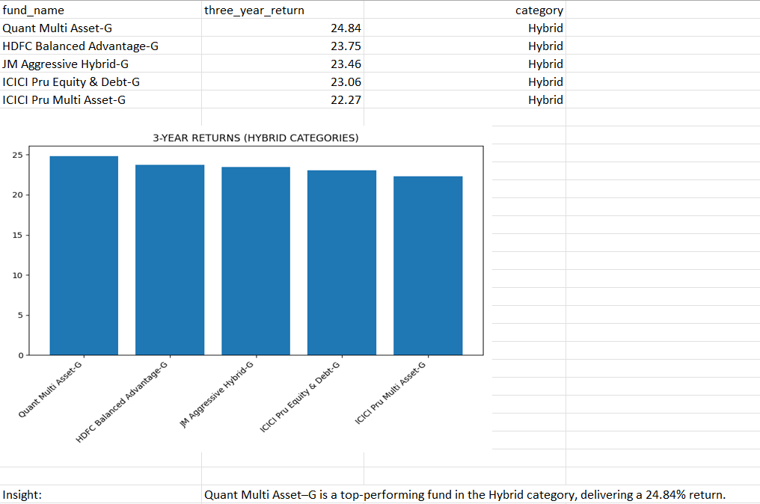

Top 5 Mutual Funds with 5-Star Ratings (Morningstar & Value Research) Based on One-Year Return-
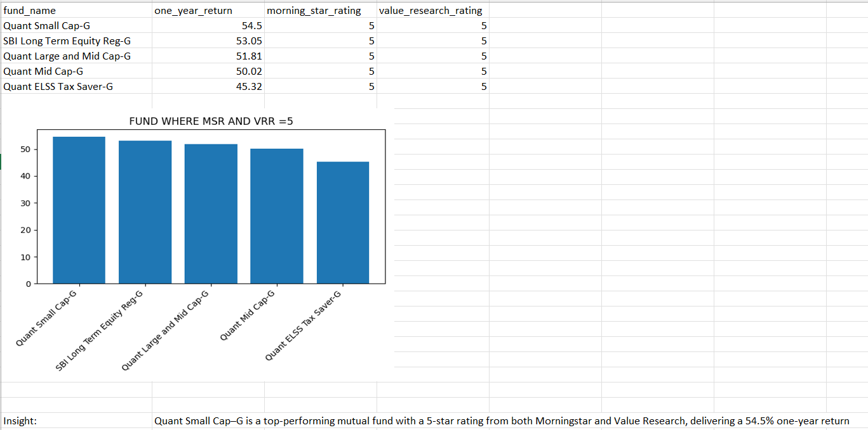
Most trusted AMC by AUM –
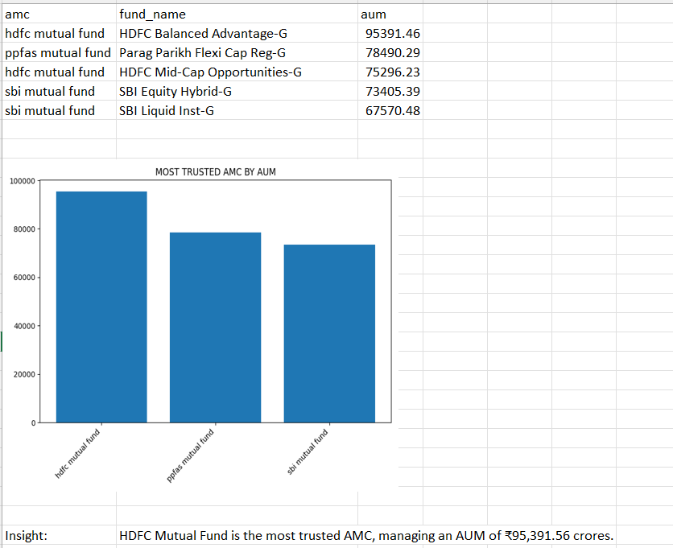
Top 5 Mutual Funds in ‘Other’ Category Based on Three-Year Return –

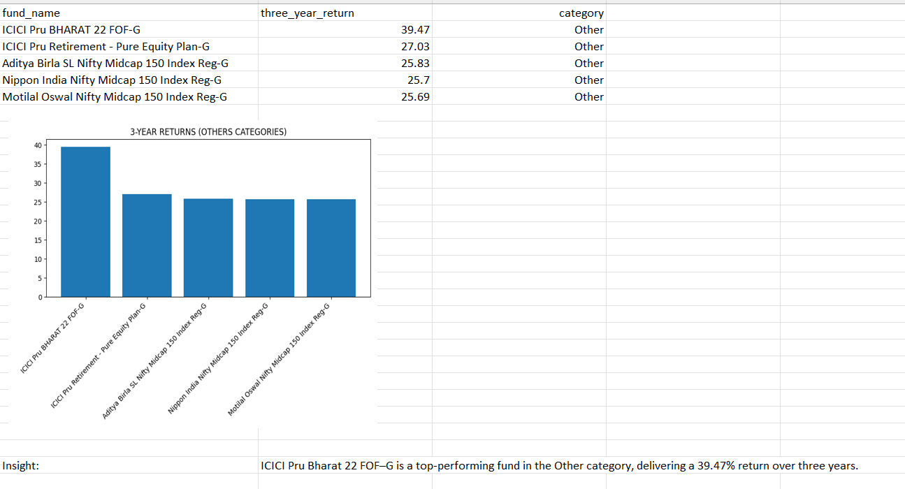
Top 5 Very High-Risk Mutual Funds Based on One-Year Return –
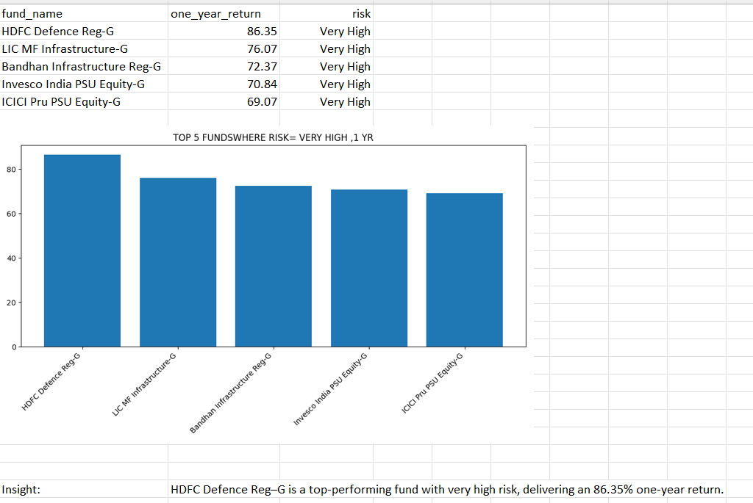
Top 5 Very High-Risk Mutual Funds Based on Three-Year Return –
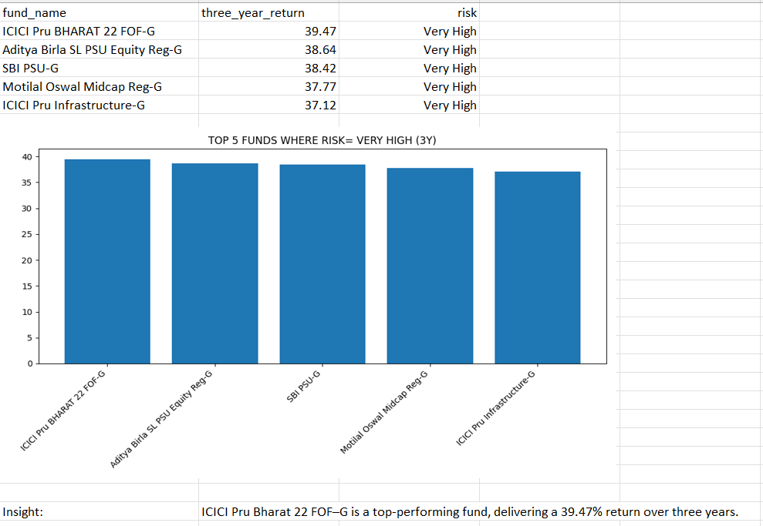
Top 5 fund managers based on 1 month return –
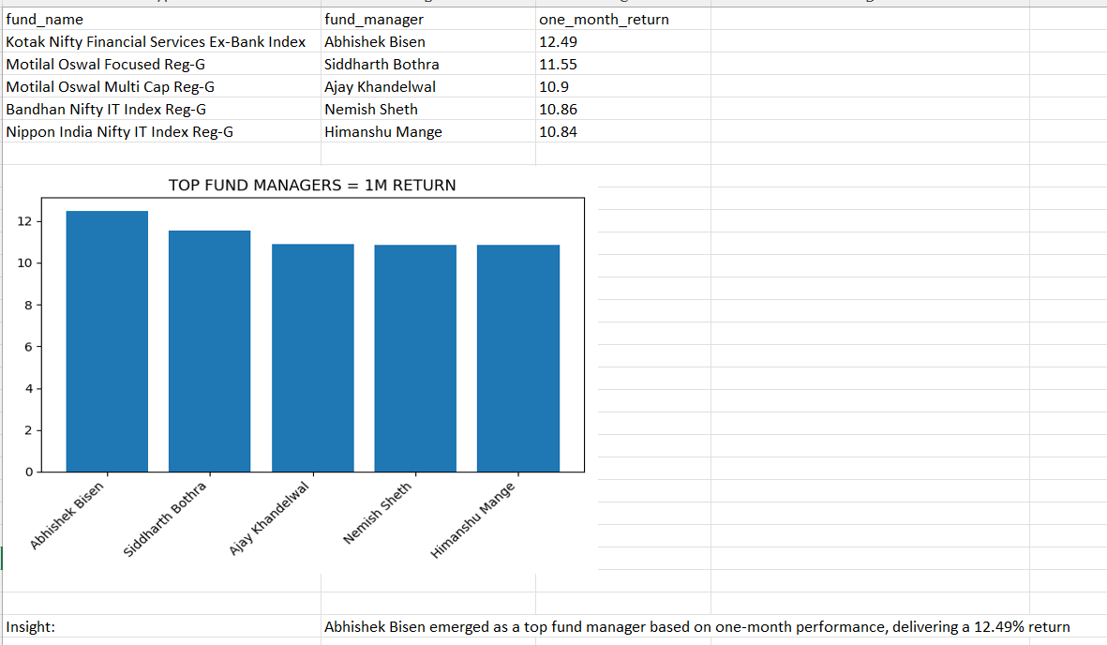
Top 5 fund managers based on 3-year return –
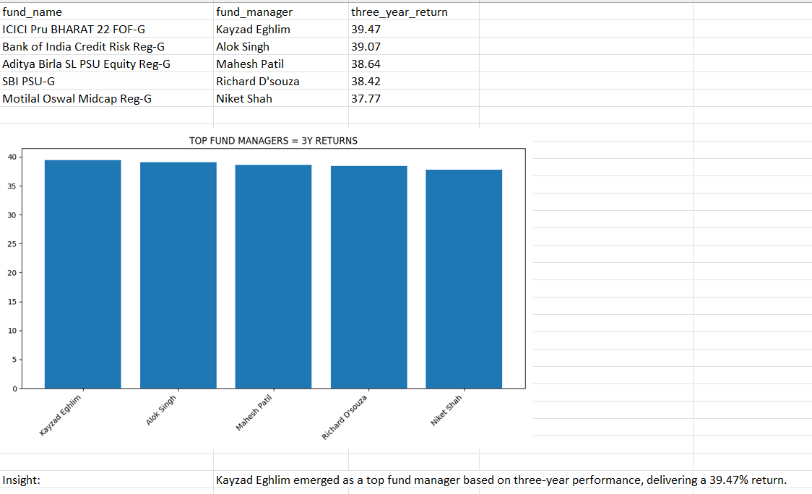
Dashboard in POWER – BI
The dashboard provides an interactive view of mutual fund performance, enabling quick comparison across returns, risk, category, AMC, and fund managers. Key components include KPI cards (e.g., Total AUM,1-month, 1-year & 3-year returns), filters for dynamic analysis, and visualizations such as stacked charts, line charts and funnel charts. It helps investors and analysts identify top-performing funds, assess risk, and make data-driven investment decisions efficiently.
